This document is a step-by-step guide on how to use OpenVas in our system..

1. Connect to the private network.. You can do this by plugging in your machine to the router, or by connecting to the network via WIFI.. **BE SURE TO DISCONNECT FROM ALL OTHER NETWORKS**
2. Find your IP Address and take note of it.. On Linux, you can type in “ip a” into the terminal, on mac, type in ipconfig getifaddr en0 (if connected wirelessly) or type in ipconfig getifaddr en1 (if connected via ethernet)
3. Open web browser of choice, and navigate to [insert ip address here]
4. Your screen may look like this..

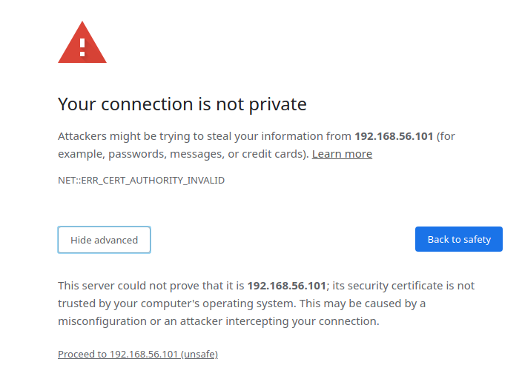

This is normal. Click “Advanced” and then click “proceed”

1. You will then be navigated to a screen that looks like this. Please use these login credentials ….

Username:

Password:

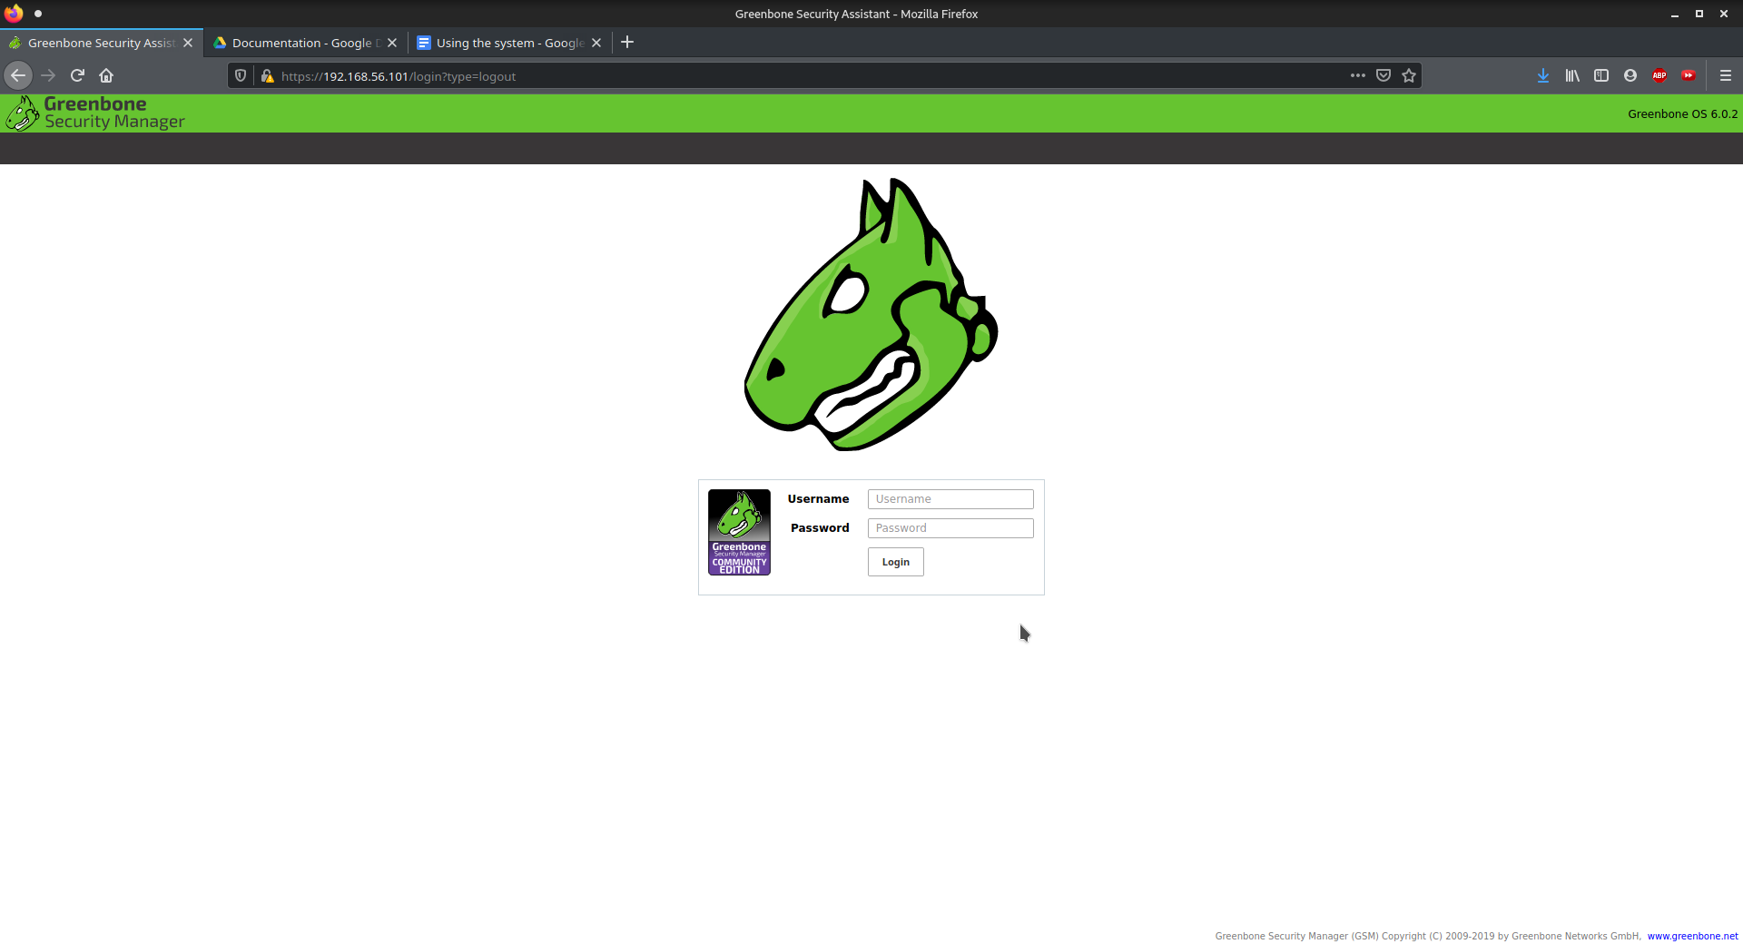

1. After logging in, you will see the security manager dashboard

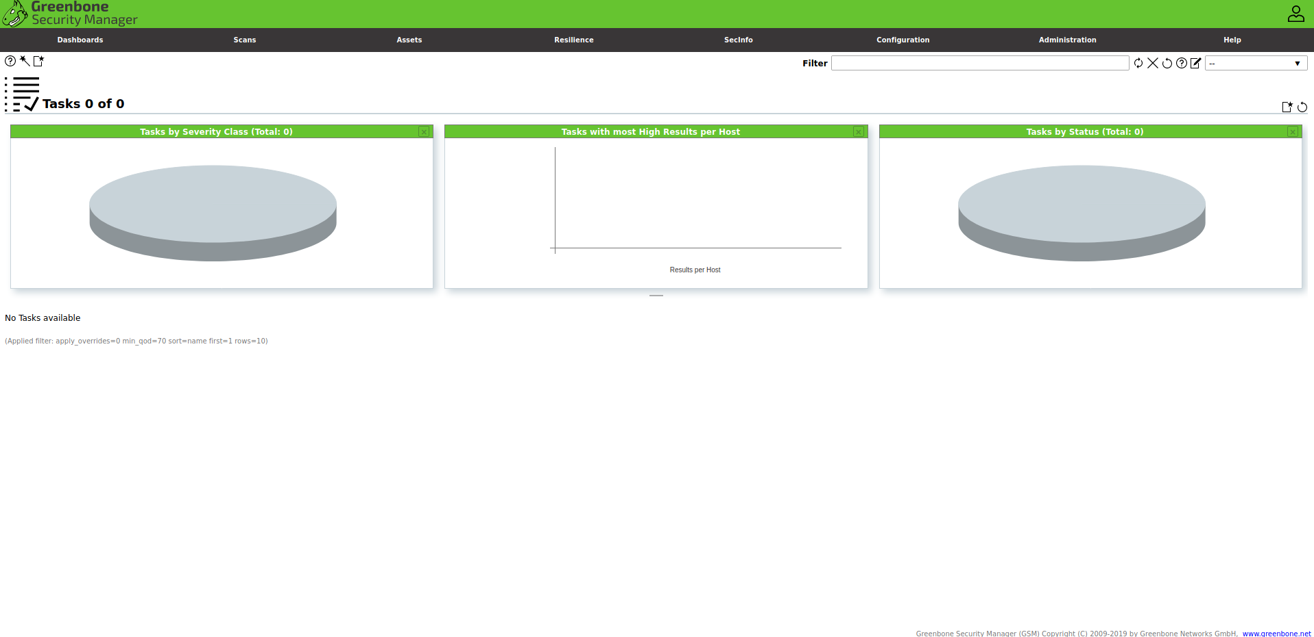

Click on this little wand icon in the top left corner of the dashboard

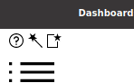

select task wizard



1. When this window pops up, enter in **YOUR IP ADDRESS that you took note of**

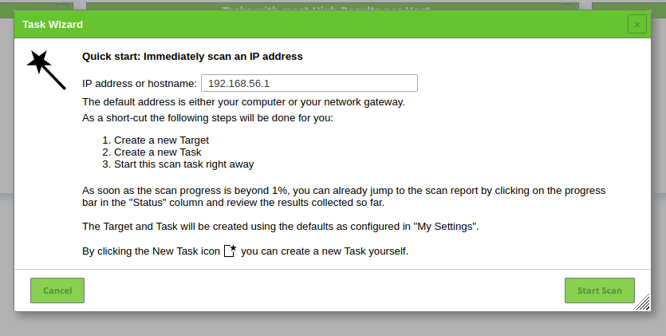

1. Your scan will begin. Wait for it to reach 100%.. The time it takes will depend on the size of your system



1. When it is done you will see the following results log



Click on the number in the reports column

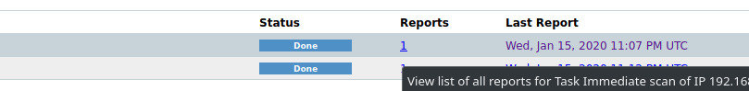

After reaching this page, click on the date of the most recent scan (which will be your scan in this case)

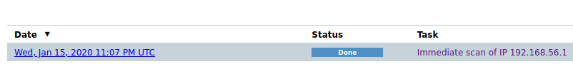

Then on the upper right, click the arrow icon and download the report

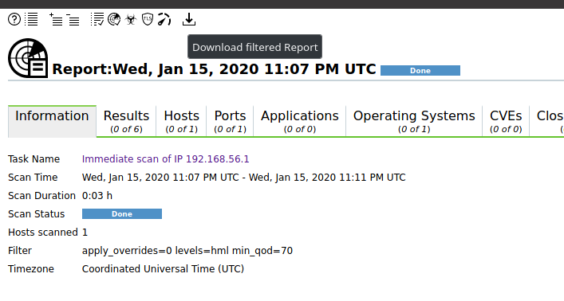

1. Save this report as a PDF (you can save it as whatever format you prefer. For the sake of this guide, we are using PDF)

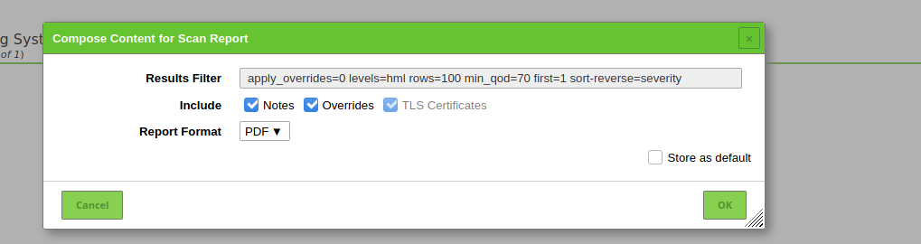

1. Open up your report. This is the first page of your report

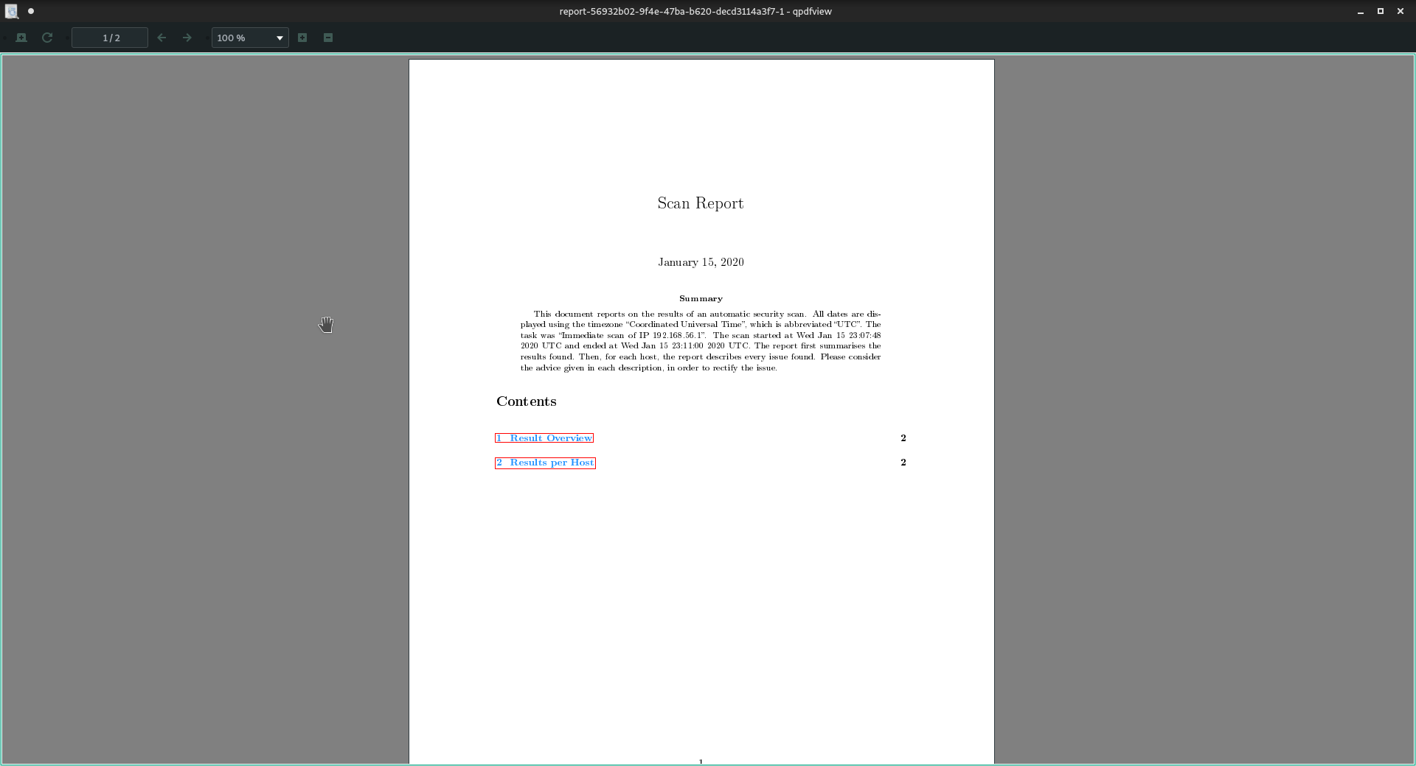

1. Navigate back to the scans page…

Delete your task by clicking on the trashcan icon on the row of your scan following the . 

Once it is deleted you may log out of the web interface by clicking on the person icon in the top right corner

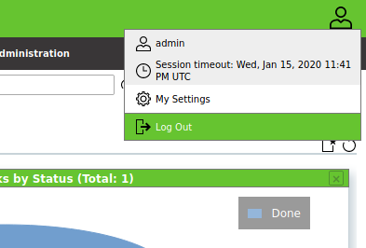

1. OPTIONAL you can now do a more thorough scan